Automobile Price Prediction using Machine Learning with Data Visualization

Revanth Kandimalla
Computer Science of Engineering
Amrita School of Engineering
Banglore.
revu5974@gmail.com

Saai Teza K
Computer Science of Engineering
Amrita School of Engineering
Banglore.
saaiteza@gmail.com

Siddardha Anagani
Computer Science of Engineering
Amrita School of Engineering
Banglore.
siddardhaanagani@gmail.com

Rakshitha K
Computer Science of Engineering
Amrita School of Engineering
Banglore.
rakshitharoyal2003@gmail.com

Mourya Vardhan Reddy M
Computer Science of Engineering
Amrita School of Engineering
Banglore.
mouryareddy@gmail.com

Abstract—With an extensive growth in usage of cars, the newly produced cars are unable to reach the customers for various reasons such less advertisement, reach or less availability of the showrooms present in the location of the consumer. Hence a high precision regression model is required which estimate the price of a car when the customer enters the description of the input of the type of car they want to have. In this model, A supervised regression model is developed using multiple regression techniques which was trained from the car dataset provided to it. This project offers a low error workable model for estimating car prices. For dependable and accurate forecasts, a large number of unique attributes are considered. The observed results are consistent with theoretical predictions and exhibit advancement over models that make use of simple linear models. Machine learning algorithms such as Tree Graph regressor and Linear Regressions. The automobile dataset is used to test these techniques. According to experimental findings, the Tree graph regressor model has generated the least amount of error out of all the other algorithms, with a score of 1 .The work reported here has significant ramifications for future research on used car price prediction using random forest, and it may one day contribute to a 100% accurate solution to the fraud problem.
Keywords—Car price prediction, Regression, Tree Graph regressor, Machine Learning, Linear regression
Introduction

There are several machine learning algorithms established, including Random Forest, Lasso, Ridge, and Linear Regressions. The automobile dataset is used to test these techniques. According to experimental findings, the Random Forest model has generated the least amount of error out of all the other algorithms, with a Mean Absolute Error value of 1.0970472 and R2 error value of 0.772584. The work reported here has significant ramifications for future research on used car price prediction using random forest, and it may one day contribute to a 100% accurate solution to the fraud problem.

Price Prediciton
The most critical piece of the vehicle business is to anticipate vehicle costs. To get this going we want a model which can gauge the cost of a vehicle to be sold with a value that is ideal for both the vehicle proprietor and the buyer. Along these lines, vehicle cost expectation has been an exploration region with extraordinary interest, as it
requires extraordinary information in the field since cost as a rule relies upon numerous particular elements and variables. There are many cases where purchasers are getting cheated by misrepresentation. Thus, we can't depend on the cost anticipated by the people as it might contain a predisposition. Consequently in this task a model which
predicts the cost of vehicles and gives the best reasonable model with the most reliable cost that anyone could hope to find on the lookout for the client utilizing the preparation that was given by the dataset and the relapse models present

Challenges
The challenges that are to overcome while designing the model will be :
- Bias towards model or price
- Unable to predict prices of very recent or very old model cars.
- Data preprocessing before regression training.
- Attributes that are supposed to be taken.

LITERATURE SURVEY
First paper is based on predicting the Price of Cars. In this paper they used various supervised techniques to estimate the price of various cars. They used the data from daily newspapers. Various Machine Learning algorithms like Support Vector Regression, Linear Regression and K-Nearest Neighbour were used.
The second part consists of the selling price prediction using Tree graph regressor machine learning algorithm by downloading the dataset from Kaggle. And here we are using tree regressor because it has scored the maximum out the other regressor techniques used for training.
The third part consists of the prediction using supervised learning techniques wherein the error rates are calculates for models like tree regressor, random forest regressor and the comparison was made for the models if they significantly differed from each other.
And finally the linear regression is done on the dataset taken from the web and Tree regressor is chosen to be the best suitable algorithm for the dataset.

Methodology

The major objective of this approach is to provide users with a precise estimate of the price that must be paid for the specified car. Depending on the specifics of the car the buyer desires, the model might provide a list of options for numerous vehicles. The system helps by giving the user access to enough information for him to draw a conclusion.
Vehicle sellers may profit from the exponential growth of the automotive industry by setting unfair pricing in order to take advantage of consumer demand. Consequently, a system that can estimate a car's price based on its specifications while simultaneously taking into account the prices of rival vehicles is required. By giving buyers and sellers an estimate of the car's value based on the best price prediction algorithm available, our method closes the gaps.

The solution is divided into the following sections:
- Data understanding and exploration
- Data cleaning
- Data preparation
- Model building and evaluation

Data understanding

- Summary of data: 205 rows, 26 columns, no null values.
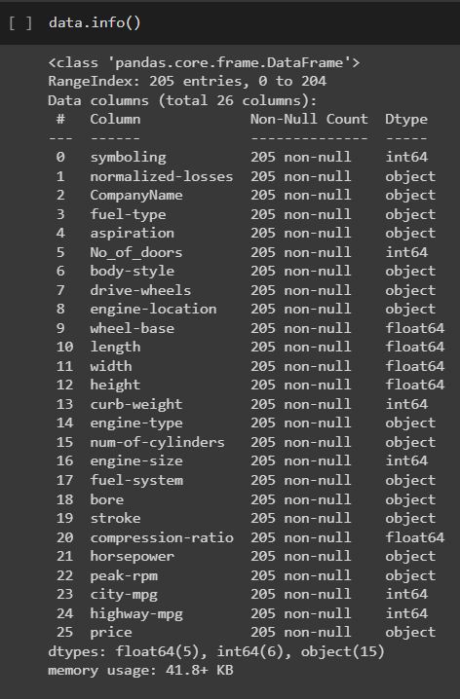
Fig(1). Dataset
- The column “Price” is the target variable and rest of the columns are independent variables.
- The independent variables are again divided into Categorical and Numerical variables.“webers/m2”. Spell out units when they appear in text: “. . . a few henries”, not “. . . a few H”.

Exploratory Data Analysis
In order to gain interesting insights from the data, we are now performing exploratory data analysis. Here are a few graphs that help us understand our data. We use a bar chart, boxplot, distribution graph, etc. to explore each feature varies
and its relation with other features including the target
feature.
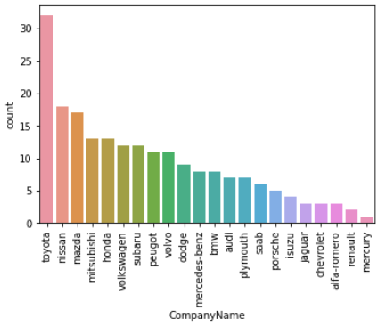
Fig(2). Count Plot
Taking a look at this plot shows that Toyota manufacturer has the highest number of cars. On the other hand, there are manufacturers such as Mercury that don’t usually have a large number of cars. There are other car brands and the number of cars that we have considered in our data as well.
Heatmap to display the relationship between the numerical and the target variable:
We create a heatmap to visualise the many relationships between numerical variables, which is really handy. We have also used it to understand the connection of numerical variables with the target variable "Price,".
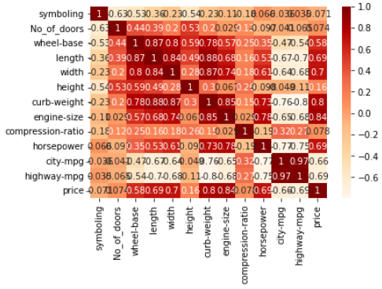
Fig(3). HeatMap
The heatmap shows some useful insights:
Correlation of target variable “Price” with independent
variables:

Price is highly (positively) correlated with wheelbase, car length, car width, curb weight, engine size, horsepower .
The relationship between price and "citympg" and "highwaympg" is negative (-0.70 approximately). This implies that vehicles with high mileage may fall into the "economy" automobile category and be less expensive.
Therefore, multicollinearity will need to be taken into consideration as we design the model (especially linear models, such as linear and logistic regression, suffer more from multicollinearity).

Data cleaning: As we can see, the dataset contains no missing values.

Additionally, we've seen that variables are formatted correctly with the exception of "symboling," which should be a category variable.

Additionally, we preprocessed the data for the field "CarName" and made a new variable named "car company.

Multicollinearity:
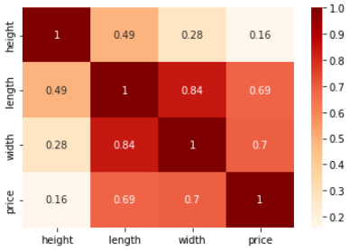
Fig(4). HeatMap after feature reduction

Car type vs Average Price:

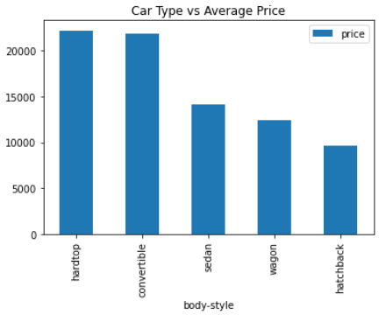
Fig(5).Bar graph of car type and average price
- Cars that are both hardtop and convertible are considerably higher in terms of prices compared to the others.

Average price of cars based on company name:
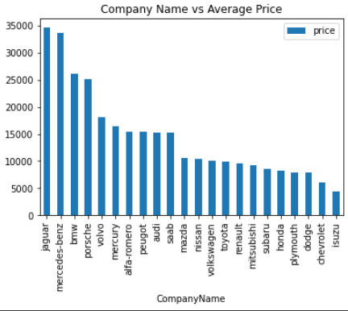
Fig(6). BarGraph of CompanyName vs Average Price
- This plot and visualisation are both quite interesting. It was obvious that Jaguar's pricing were much higher than those of all the other manufacturers combined. Other companies like Mercedes-Benz, BMW, and Porsche are in the same price range as Jaguar manufacturers.
Box Plot:
- Box plot is used to identify the outliers of integer attribute.
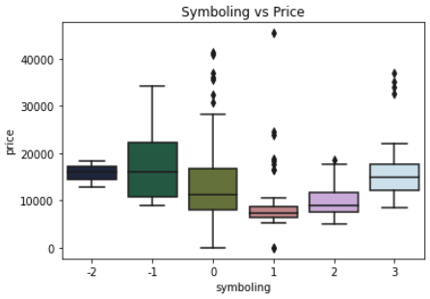
Fig(7). BoxPlot of Symboling and Price
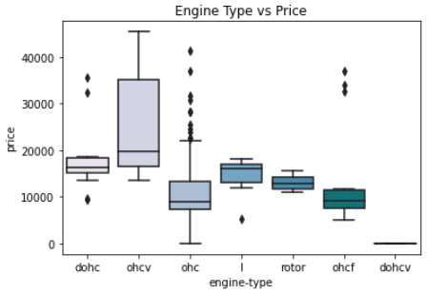
Fig(8).BoxPlot of Engine Type and price

IV. Model Description
There is a regression problem at hand. We experimented with decision trees and linear regression. After extensive testing, it was found that Decision Tree performed significantly better since it solved the overfitting issue. F-score accuracy, precision, and recall are all 100%. One is most accurate.
- These trees grow very deep and, by being trained on selected portions of the dataset, help in the discovery of very irregular patterns. But this can result in an overfitting problem. In order to reduce variance and assure consistency, this is handled by averaging out each tree's predictions.

Dataset pre-processing
Input modification or encoding is the process of pre-processing which makes data easier for the computer to parse. The algorithm can now correctly comprehend the data as a result.
After pre-processing, the final dataset contains features for cars such as– 'price', 'vehicle Type', ‘curb weight’, 'horse power', 'model', 'kilometer', 'fuel Type', 'brand', and 'engine size',. Out of these features, the most important for our prediction model is
1. price: The specified asking amount for the car .
2. kilometer: Number of Kilometers the car has driven .
3. brand: The car’s manufacturing company.
4. vehicle Type: Whether a small car, limousine, bus, etc.
5. Curb weight: The total weight of the car.

Training and Testing
Our input data were divided into training and testing data. In order to balance the training and testing data over the entire dataset, the splitting was carried out by selecting at random. This is done in order to prevent overfitting and improve generalisation.

Accuracy
The model score is the coefficient of determination R^2 of the prediction. With a score of 0.98, the decision tree regressor performs well by giving the testing dataset's accuracy.

Only key aspects were kept when the model was refined, leaving the rest behind. Utilizing correlation, the significant characteristics are identified and their contribution to the calculation of a vehicle's cost is evaluated. Overall, the decision tree model gave precise predictions for the price of the automobile and successfully captured the details of the data.

Linear Regression

Before applying a linear regression model, we first define an instance of it. We then fit our training data after this step. Later, before the model produces a forecast, we feed it the results of our test data. The mean squared error and r2 score are then added so they can later be plotted.

Mean square root : 1.776527482120706e-30
r2 score : 1.0

We see that the linear regression model is doing quite well in terms of its prediction of the prices.

In the below picture, we plotted the linear graph for highway.mpg and city.mpg.
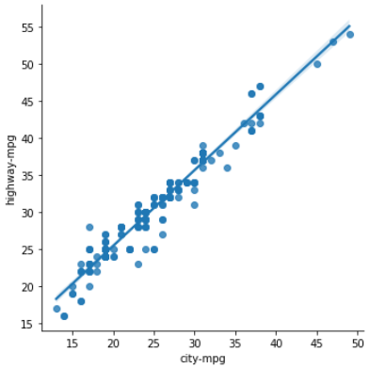
Fig(9).Scatter plot of city mpg vs highway mpg
In the below picture we plotted linear plot for engine
Size and horsepower.

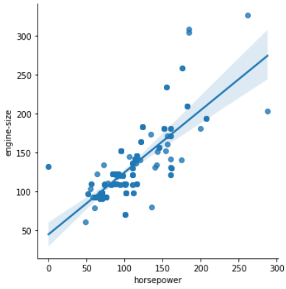
Fig(10). Scatter plot of horsepower and engine size.

For the decision tree, we have got score as 1 for both training set and testing set. So we consider this as best.

Linear Regression score : 1.0
Tree Graph Classifier Score : 1.0

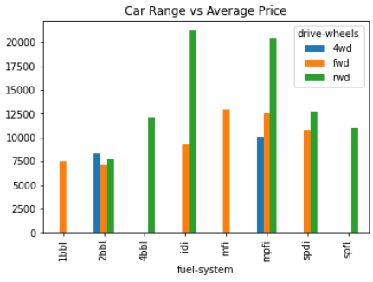
Fig(11). Bar graph of car range and average price .

The above picture shows the predicted car range with average price.

Data Visualization
Data visualization uses visual components like graphs, charts, and maps to graphically portray quantitative information and data. Data visualization turns both huge and small data sets into graphics that are simple for people to comprehend and process. Data outliers, patterns, and trends can be easily understood with data visualization tools. The tools and technology for data visualization are essential in the realm of big data because they allow for the analysis of enormous amounts of data.
Distribution between two classes is plotted by scatter plot. The link between various variables is displayed using a scatter plot, a sort of data visualization. Placement of numerous data points between an x- and y-axis is used to display this data. This kind of data visualization gets its name from the way that each of these data points appears to be "scattered" throughout the graph.
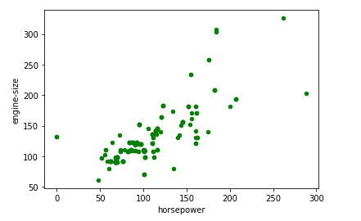
Fig(12). Scatter plot of horsepower and engine size.

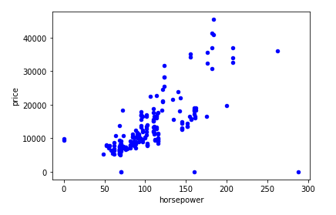
Fig(13). Scatter plot of horsepower and price.
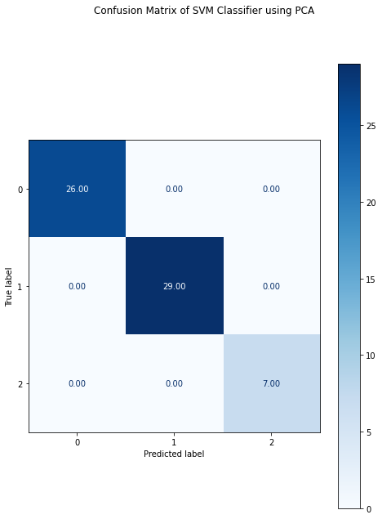
Fig(14). Confusion Matrix By using SVM classifier

Pie chart

The pie chart is a pictorial representation of data that makes it possible to visualize the relationships between the parts and the whole of a variable.

Like a pie chart, the total of the data that make up the segments must equal 360°, or the sum of the values of the circumference must always be 100%.
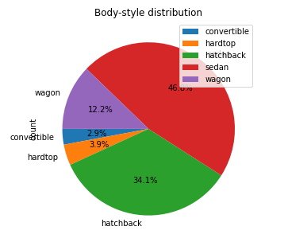
Fig(14).PieChart depicting Body-style distribution and count
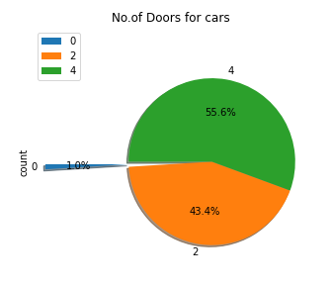
Fig(15). Pie chart depicting no of doors and count
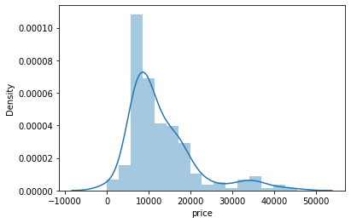
Fig(16). DistPlot of Price

Sampling
A statistical analysis approach called data sampling is used to choose, alter, and study a representative selection of data points in order to spot patterns and trends in the broader data set being reviewed.

a)Simple Random Sampling
A simple random sample is a population subset that has been chosen at random. With this sampling technique, every person in the population has the exact same probability of getting chosen. Since it only includes one random selection and requires little prior population knowledge, this method is the easiest of all the probability sampling techniques. Any research conducted on this sample should have high internal and external validity because randomization was used, and there should be less chance of biases like sampling bias and selection bias.

b)Systematic Sampling
A probability sampling technique called systematic sampling involves researchers choosing people from the community at predetermined intervals (or k). This method will provide you with a representative sample from which you can make conclusions about your target community if the population order is random or random appearing (for example, alphabetical).

c)Clutser Sampling
In cluster sampling, researchers separate a population into clusters, which are smaller groups. They then choose at random from these clusters to create a sample. Large populations, especially those that are widely geographically distributed, are frequently studied using the probability sampling technique known as cluster sampling. As their clusters, researchers frequently choose pre-existing units like cities or schools.

Classifiers

K Nearest Neighbour
Both classification and regression issues are addressed by the K Nearest Neighbors (KNN) technique. It maintains a database of all known use cases and categorizes newly discovered use cases (or data points) by grouping them into several classifications. Based on how closely the most recent use cases match the ones that are already available, this classification is completed.

Gaussian Naïve Bayes
When discussing classification issues, the term "Naive Bayes" refers to a probabilistic machine learning technique based on the Bayesian probability model. The algorithm's essential premise is that the qualities being considered are unrelated to one another and that changing the value of one does not affect changing the value of the other.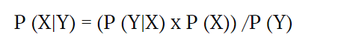

Support Vector Machine
Both regression and classification tasks are completed using support vector machine methods. These are supervised machine learning techniques, where n is the number of features, and where each piece of data is plotted in an n-dimensional space. It is simpler to plot the features because each feature value has a corresponding coordinate value.

Linear Regression
The relationship between an input variable (x) and an output variable (y), also known as independent and dependent variables, is shown via linear regression. To further comprehend the algorithm, consider the scenario where you must place a few plastic boxes of various sizes on various shelves according to their respective weights. It is necessary to perform the work without physically weighing the boxes. The weight must instead be estimated based solely on the height, width, and depth of the boxes. Simply said, visual analysis serves as the foundation for the entire task. As a result, the final configuration of the shelves must be created using a mix of visible factors.

Multilayer Perceptron
Multilayer perceptron is made up of dense, completely connected layers that may change any input dimension into the desired dimension. A neural network with numerous layers is referred to as a multi-layer perception. When neurons are combined, some neurons' outputs become the inputs for other neurons, forming a neural network

Decision Tree
You may see the road map of possible outcomes for a sequence of decisions using a decision tree. It lets businesses to weigh different outcomes and then make an easy choice based on factors that benefit them, like advantages and probabilities.

K means Clustering
Clustering tasks are carried out via the distance-based unsupervised machine learning algorithm K-Means. With the help of this approach, you may group datasets into clusters (K clusters), where the data points from one cluster remain homogeneous and the data points from two distinct clusters remain heterogeneous.

After analyzing and comparing accuracies of all the algorithms mentioned, “SVM” is having more accuracy than others. Hence, we consider Support Vector Machine as our model to predict the given image mapping to the classes from 0-9.

Conclusion
The price of a car depends on a lot of factors like the goodwill of the brand of the car, features of the car, horsepower, and the mileage it gives and many more.
Data cleaning is one of the processes that increases prediction performance, yet insufficient for the cases of complex data sets as the one in this research.
Car price prediction can be a challenging task due to the high number of attributes that should be considered for the accurate prediction. The major step in the prediction process is collection and preprocessing of the data.
If one ignores the brand of the car, a car manufacturer primarily fixes the price of a car based on the features it can offer a customer. Later, the brand may raise the price depending on its goodwill, but the most important factors are what features a car gives you to add value to your life.
In the case of car prices prediction, companies could use this technology to determine the prices of new cars that they produce which will help them to set the most accurate prices for their cars based on the market value of cars. As a result, optimal prices for cars could be set leading to better growth and outcomes for car manufacturers respectively.
Although this system has achieved astonishing performance in car price prediction problem our aim for the future research is to test this system to work successfully with various data sets

Acknowledgment
The authors of this paper would like to express their gratitude to the Faculty of Foundations of Data Science, Dr.B.Uma Maheswari for supporting us in this research. Also, we would like to acknowledge the use of Google Colab integrated with Python for the creation of the data visualizations presented in this paper. Without these tools it’s not possible for us to understand and analyse the data. Their assistance was essential to the success of our study.

References
- https://towardsdatascience.com/predicting-car-price-using-machine-learning-8d2df3898f16)

- https://medium.com/odscjournal/predicting-car-prices-using-machine-learning-and-data-science-52ed44abab1b

- https://arxiv.org/ftp/arxiv/papers/1711/1711.06970.pdf

- https://scholarworks.rit.edu/cgi/viewcontent.cgi?article=12220&context=theses

- https://ieeexplore.ieee.org/document/9696839

